CT Lung Cancer Prediction using CNN

Mr.Saravana Kumar .M | Mr.Arockia Jerin .J | Mrs.Sheebha.S.N
BE CSE (Final year) | BE CSE (Final year) | Assistant Professor/CSE
mrsarvan87@gmail.com | arockiyajerin26@gamil.com
Dr.G.U. Pope College of Engineering | Dr.G.U. Pope College of Engineering | Dr.G.U. Pope College of Engineering

Abstract- Lung cancer remains a leading cause of global morbidity and mortality, necessitating advanced diagnostic tools for early detection and intervention. This project introduces a novel approach to lung cancer prediction by leveraging Convolutional Neural Networks (CNN) on lung X-ray images. The CNN model is trained to classify lung X-rays into four categories: adenocarcinoma, large cell carcinoma, normal, and squamous cell carcinoma. The methodology involves preprocessing of lung X-ray images, feature extraction using CNN layers, and classification through a carefully designed neural network architecture. The model's training is based on a dataset encompassing a diverse range of cases, facilitating robust learning and accurate predictions. The significance of this project lies in its potential to enhance early detection and streamline diagnosis, leading to timely medical interventions. By automating the categorization of lung cancer types through CNN analysis of chest X-rays, this system aims to contribute to the efficiency of healthcare services and improve patient outcomes. The evaluation of the proposed model involves comprehensive performance metrics, including accuracy, sensitivity, specificity, and precision. Results from extensive testing on diverse datasets showcase the model's efficacy in distinguishing between various lung cancer types and identifying normal cases.
Keywords -CNN, Neural network, lung cancer, deep learning algorithm

INTRODUCTION

Lung sickness is a significant general wellbeing concern around the world, with pneumonia, cellular breakdown in the lungs, and persistent obstructive pneumonic illness (COPD) affecting huge number of individuals every year. Early and right conclusion of these problems is basic for effective treatment and the board. Profound learning, a kind of man- made consciousness (simulated intelligence), has arisen as a powerful method for clinical picture handling, with the possibility to increment indicative exactness and proficiency. Convolutional Neural Network (CNN) are a kind of profound learning model that is especially valuable for picture handling. CNNs might learn confounded examples and characteristics related with different lung illnesses by using
enormous information bases of clinical pictures.
A growing number of people are interested in using CNNs to predict lung diseases, which could revolutionize medical diagnosis and treatment planning. CNNs expect the arrangement of profound learning-based lung. The's undertaking will probably make a model that can precisely foresee the presence or nonappearance of lung sickness utilizing clinical imaging information like lung X-Rays or CT scan. Via preparing the CNN on a fluctuated and delegate assortment of lung examines, we desire to use the capability of profound figuring out how to improve demonstrative exactness and convey early treatments to patients with lung issues.
Eventually, the objective is to make a trustworthy and productive instrument that will help medical care professionals successfully analyze and oversee lung issues, at last working on understanding results and personal satisfaction.

LITERATURE REVIEW

“Segmentation and Prediction of Lung Cancer CT Scans through Nodules using Ensemble Deep Learning Approach”,the paper is The focus on division and prediction of cellular disintegration in the lungs. CT examination of knobs using a group profound learning approach yields promising results. We achieved greater precision and power in knob division and disease forecasting by coordinating many models. This method has the potential to improve early detection and analysis of cellular breakdown in the lungs, providing great assistance to radiologists and doctors. Further examination and approval are justified to assess its clinical suitability across diverse patient populations and medical care settings.
“A Deep Learning Based Approach to Predict Lung Cancer from Histopathological Images”. The results of a study on the application of deep learning to the prediction of lung cancer from histopathological pictures would probably indicate that deep learning models are capable of reliably identifying and predicting the presence of lung cancer through effective analysis of these images. By providing an accurate and timely diagnosis, these models have the potential to improve patient outcomes by enabling earlier intervention and treatment
“A Lightweight Deep Learning Model for Automatic Diagnosis of Lung Cancer”. The project focuses on developing a lightweight deep learning model for the automatic diagnosis of lung cancer. Extensive research and review have shown that the model is effective and efficient at accurately categorising

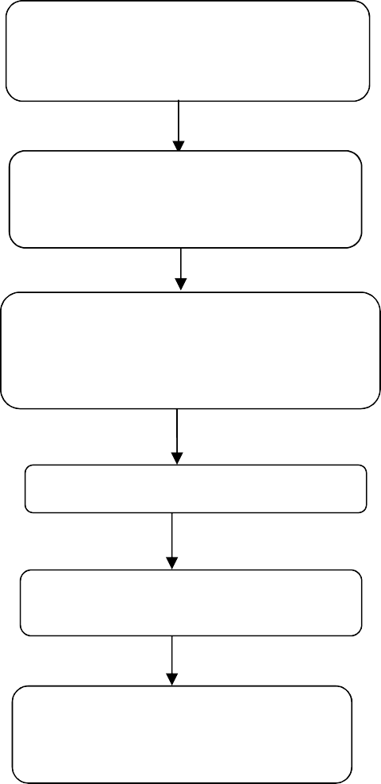
lung cancer cases based on medical imaging data. The proposed approach appears to be a promising method for speeding up and improving the accuracy of lung cancer diagnosis. This could result in early detection and better outcomes for patients. Further testing and approval in clinical settings are required to fully assess the therapeutic utility and versatility of the suggested paradigm.
preprocessing block
- resizing
- normalization

cnn architecture
(feature extraction)

fully connected layers

Classification output

evaluation metrics block

- accuracy
- recall/
ROC-AUC

- Existing System

LUNA16: The Lung Nodule Analysis (LUNA16) challenge was a widely recognized competition in the field of lung cancer detection from CT scans. While it's not a system per se, it provided a benchmark dataset and a platform for researchers to develop and evaluate lung cancer prediction algorithms. Many research papers and code implementations have been built upon this challenge.

DeepLung: DeepLung is an open-source project developed by researchers at the University of Central Florida, aimed at detecting lung nodules from CT scans using deep learning techniques. It provides a TensorFlow-based implementation of various deep learning models for lung nodule detection and classification.

CheXNet: Although primarily focused on chest X-ray analysis for various pathologies, including pneumonia, CheXNet, developed by researchers at Stanford University, demonstrated the potential of deep learning in medical image analysis. While not specifically for lung cancer prediction, the techniques and methodologies used in CheXNet could be adapted for similar tasks.

IBM Watson for Oncology: IBM Watson for Oncology is a commercial system that utilizes artificial intelligence, including deep learning algorithms, to assist oncologists in making treatment decisions for cancer patients. While it's not solely focused on lung cancer prediction, it showcases the integration of AI into clinical decision-making processes.
Google AI's Research on Lung Cancer Prediction: Google's DeepMind Health team has conducted research on using deep learning algorithms to predict lung cancer from CT scans. While their work is primarily research-oriented, it highlights the potential of deep learning in improving early detection and diagnosis of lung cancer.

PROPOSED SYSTEM

The cellular breakdown in the lungs forecast framework comprises of a few primary parts, every one of which is expected to work on the prescient model's general exactness and utility. The main module includes information preprocessing, in which chest X-Ray pictures are exposed.

PROPOSED BLOCK DIAGRAM:
CT scan dataset

Fig. 1. Block Diagram of Proposed System

Thorough cleaning, standardization, and expansion cycles to guarantee the dataset's optimal quality and consistency. This stage is basic for working on the model's ability to identify minor examples that demonstrate unmistakable types of cellular breakdown in the lungs. It focuses on the design and preparation of the Convolutional Neural Network (CNN). This includes the careful selection and design of lungs network layers, such as convolutional layers for highlight extraction and fully related layers for characterization. The model is based on a distinct dataset that includes adenocarcinoma, large cell carcinoma, squamous cell carcinoma, and typical instances. optimisation techniques are employed during training to fine-tune the model's parameters for best performance.

After the preparation stage, the third module centers around coordinating and conveying the prepared CNN model. The development of an interface that enables healthcare providers to submit chest X-ray images for real-time analysis is the objective of this module. The program creates expectations for each picture, sorting it as both of the predefined cellular breakdown in the lungs sorts or typical. Coordination contemplations

incorporate easy to understand points of interaction, versatility, and consistent correspondence between the model and the client

The fourth module involves rigorous testing and validation. The presentation of the framework is evaluated using many metrics such as exactness, awareness, particularity, and accuracy. Testing covers a variety of datasets to ensure the model's power and generalizability. Criticism from clinical professionals is also sought to further enhance the model and address any potential issues in certifiable clinical situations.

At last, the fifth module covers the understanding and representation of results. This involves getting pertinent experiences from the model's expectations, for example, recognizing huge areas in X-Ray pictures that add to order. Representation methods are utilized to help clinical professionals appreciate and trust the model's decisions, expanding straightforwardness and interpretability.

This technique ensures an ordered and comprehensive improvement process, which includes information planning, model creation, organisation, testing, and result translation. The combination of these modules aims to express a refined and solid cellular breakdown in the lungs' expectation framework, with the potential to significantly influence early conclusion and work on comprehending findings.

SOFTWARE USED

Anaconda, as mentioned earlier, is not a specific tool for cancer prediction or deep learning. However, it provides an environment conducive to developing such projects. If you're working on cancer prediction using deep learning, particularly Convolutional Neural Networks (CNNs), Anaconda can be extremely helpful in managing your Python environment and dependencies.

Environment Setup: Anaconda allows you to create isolated Python environments, which is beneficial for managing dependencies. You can create a new environment specifically for your cancer prediction project, ensuring that you have all the necessary libraries installed without conflicting with other projects or system-wide packages.

Installing Deep Learning Libraries: Anaconda's package manager, conda, and its associated package repository, conda- forge, provide easy access to popular deep learning libraries like TensorFlow, PyTorch, and Keras. You can use conda to install these libraries into your project environment.

Data Handling and Preprocessing: Utilize libraries like pandas for data handling and manipulation. For image data, you might use libraries like OpenCV to load and preprocess images before feeding them into your CNN model.
Model Development: With deep learning libraries like TensorFlow or PyTorch installed via Anaconda, you can develop CNN models for cancer prediction. These libraries provide high- level APIs for building neural networks, including convolutional layers for image analysis.

Training and Evaluation: Train your CNN model on your dataset using the capabilities of TensorFlow or PyTorch. Anaconda's environment management ensures that you have all the required dependencies for training and evaluation in a consistent environment.

Visualization and Analysis: Anaconda includes libraries like matplotlib and seaborn, which are useful for visualizing data and model performance metrics. You can use these libraries to analyze the results of your cancer prediction model.

Overall, while Anaconda itself isn't specifically designed for cancer prediction or deep learning, it provides a powerful environment for managing dependencies and developing deep learning models using libraries like TensorFlow or PyTorch, which are commonly employed in such projects.

PROTOTYPE MODEL
INPUT:
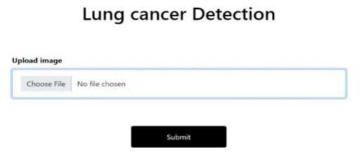

Fig 2: Input image 1

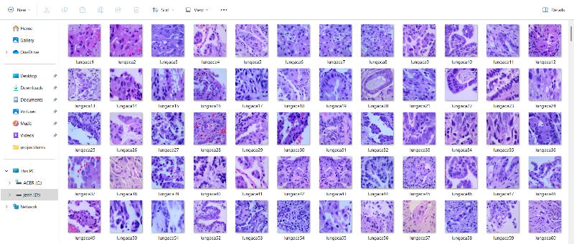

Fig 3: Input image 2

OUTPUT
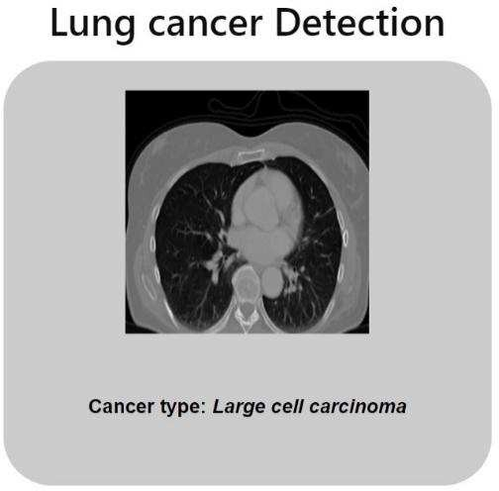

Fig 4 : Output image

VII Results And Discussions

In result of, this project represents a significant stride in the realm of medical diagnostics, specifically in the early detection of lung cancer using X-rays. By harnessing the power of Convolutional Neural Networks (CNN), our system demonstrates a robust capacity to classify diverse lung cancer types—adenocarcinoma, large cell carcinoma, squamous cell carcinoma—and normal cases with notable accuracy.
The meticulously designed modules, ranging from data preprocessing to model deployment and result interpretation, collectively form a comprehensive pipeline. Through extensive testing on varied datasets and continual refinement based on medical professional feedback, the system exhibits not only promising predictive capabilities but also a potential for practical integration into clinical workflows.
The fusion of advanced technology with healthcare in this project underscores the transformative impact that artificial intelligence can have on early diagnosis, thereby offering a valuable tool to the medical community in the ongoing battle against lung cancer. This project stands as a testament to the convergence of cutting-edge technology and healthcare, with the overarching goal of improving patient outcomes and contributing to the advancement of medical science
VIII Conclusion

In conclusion, this work offers a tremendous progression in the field of clinical diagnostics, remarkably the early determination of cellular breakdown in the lungs using X-Ray. It utilizes Convolutional Neural Network (CNN) to characterize different cellular breakdown in the lungs types — adenocarcinoma, enormous cell carcinoma, and squamous cell carcinoma — as well as expected cases with high precision. The exactly evolved modules, which range from information preprocessing to demonstrate sending and result understanding, make up an exhaustive pipeline. Through far reaching testing on different datasets and progressing change in light of clinical expert criticism, the framework shows great
prescient abilities as well as the potential for commonsense mix into clinical work processes. The undertaking's combination of refined innovation and medical services features the emotional impact that man-made brainpower can have on early conclusion, giving a significant device to the clinical local area in the continuous conflict against cellular breakdown in the lungs. This drive epitomizes the crossing point of state of the art innovation and medical services, with a definitive objective of working on persistent results and adding to the progression of clinical science.

REFERENCES

- Muthazhagan B, Ravi T, Rajinigirinath D. An enhanced computer-assisted lung cancer detection method using content-based image retrieval and data mining techniques. Journal of Ambient Intelligence and Humanized Computing. June 2 2020 :pp 1-9.
- Masud M, Sikder N, Nahid AA, Bairagi AK, AlZain MA. A machine learning approach to diagnosing lung and colon cancer using a deep learning-based classification framework. Sensors. Jan;21 2021 .
- Sajja T, Devarapalli R, Kalluri H. Lung Cancer Detection Based on CT Scan Images by Using Deep Transfer Learning. Traitement du Signal. Oct;36(4):339-44 2019
- Sajja T, Devarapalli R, Kalluri H. Lung Cancer Detection Based on CT Scan Images by Using Deep Transfer Learning. Traitement du Signal. Oct;36(4):339-44 2019
- Detection and classification of lung cancer using CNN and Google netR. Pandian *, V. Vedanarayanan, D.N.S.
Ravi Kumar, R. Rajakumar
- Deep learning ensemble 2D CNN approach towards the detection of lung cancer AsgharAli Shah1, HafzAbid Mahmood Malik2*, AbdulHafeez Muhammad1AbdullahAlourani3 & Zaeem Arif Butt1
- Ahmed Medjahed S., AitSaadi T., Benyettou A., Ouali
M. Kernel-based learning and feature selection analysis for cancer diagnosis. Applied Soft Computing . 2017;51:39doi: 10.1016/j.asoc.2016.12.010
- Deepa N., Prabadevi B., Maddikunta P. K., et al. An AI- based intelligent system for healthcare analysis using Ridge-Adaline Stochastic Gradient Descent Classifier. The Journal of Supercomputing . 2021;77(2):1998–2017.
doi: 10.1007/s11227-020-03347-2
- Yu K. H., Zhang C., Berry G. J., et al. Predicting non- small cell lung cancer prognosis by fully automated microscopic pathology image features. Nature Communications . 2016;7(1):p. 12474.
doi: 10.1038/ncomms12474
- Cirujeda P., Cid Y. D., Muller H., et al. A 3-D Riesz- covariance texture model for prediction of nodule recurrence in lung CT. IEEE transactions on medical imaging . 2016;35(12).

